Lab_Day-24 ANP-C8906 (Matplotlib more plots and formatting)

1: Analyze the relationship between the size of houses (measured in square footage) and their selling prices in a particular neighborhood. You have collected data on various houses in that neighborhood.Create a scatter plot using the below data and share your conclusion/analysis.

Input: square_footage = np.array([1200, 1400, 1600, 1800, 2000, 2200, 2400, 2600, 2800, 3000])

selling_prices = np.array([250, 290, 315, 380, 410, 450, 500, 525, 570, 610])

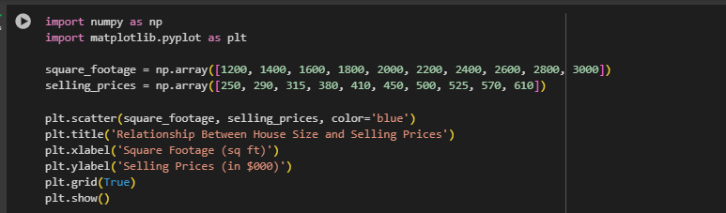

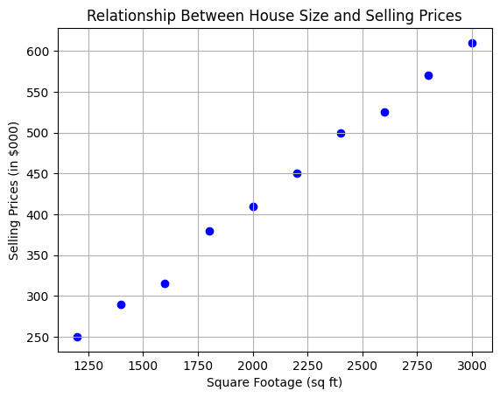

2. Create a pie chart to visualize the distribution of your monthly income by source. You have collected data on the various sources of your income, such as salary, freelance work, investments, and rental income. Share your conclusion/analysis.

Input: income_sources = ['Salary', 'Freelance', 'Investments', 'Rental', 'Other']

monthly_income = [5000, 1500, 1000, 600, 400]

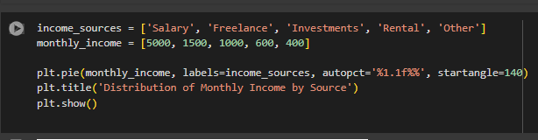

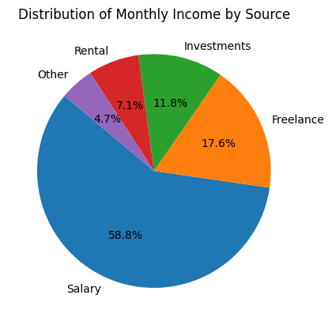

3: Create a pie chart to illustrate the distribution of a company's revenue across its various business segments. You have collected data on the revenue generated by each segment, such as Product A, Product B, Services, and Licensing. Share your conclusion/analysis.

Input: segments = ['Product A', 'Product B', 'Services', 'Licensing']

revenue_percentages = [45, 25, 15, 15]

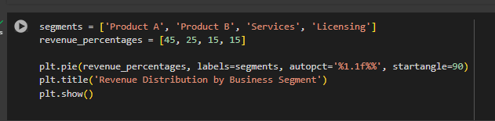

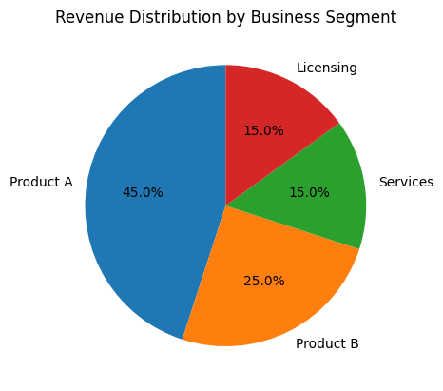

4: Suppose you're a sales manager for an e-commerce company, and you want to create a figure with subplots to compare the sales performance of different product categories over time. You have sales data for four product categories: Electronics, Clothing, Home & Garden, and Sports & Outdoors. Share your conclusion/analysis.

Input: months = np.arange(1, 13)

electronics_sales = np.array([25000, 28000, 31000, 27000, 30000, 32000, 35000, 36000, 38000, 39000, 41000, 42000])

clothing_sales = np.array([15000, 16000, 17000, 18000, 19000, 20000, 21000, 22000, 23000, 24000, 25000, 26000])

home_garden_sales = np.array([18000, 19000, 20000, 21000, 22000, 23000, 24000, 25000, 26000, 27000, 28000, 29000])

sports_outdoors_sales = np.array([12000, 13000, 14000, 15000, 16000, 17000, 18000, 19000, 20000, 21000, 22000, 23000])

